*Spirit Wear orders placed as needed*

Black Zipper Hoodie Sweat Shirt, S – M – L – XL, $31.00_____, 2XL $34.00______, 3XL $37.00______;

Black Hoodie Pullover Sweat Shirt, S – M – L – XL, $27.00_____, 2XL $30.00______, 3XL $33.00______;

Black Sweat Pants w/pockets** S – M – L – XL, $27.00_____, 2XL $30.00______, 3XL $33.00______; ***Option 1 or 2***

Black Crewneck Sweat Shirt, pull over, S – M – L – XL, $22.00_____, 2XL $24.00______, 3XL $26.00______;

V Neck Wind Shirt, pull over, S – M – L – XL, $50.00_____, 2XL $56 .00______, 3XL $60.00 ______;

*Choose Color:* shown on page two, Red/Black____, Black/Red_____

Black shorts men, 9” inseam, ** S – M – L – XL, $22.00 _____; 2XL $26.00_____; ***Option 1 or 2***

Black cheer shorts women, 3” inseam, ** S – M – L – XL, $20.00 _____; 2XL $24.00_____; ***Option 1 or 2***

Knit cap, Black _______, Red/Black Stripe______, $16.00 _____;

Baseball cap adjustable, Red w/Black piping_____; Black w/Red piping_____; $18.00 _____;

MK Red Polo’s (current style) S – M – L – XL – 2XL, $35.00_____

MK Red Polo’s (former style 2014-15) only XL – 2XL, $15.00 _____ (Sizes and quantity limited)

MK Red/Black (former style, salt and pepper) only XL – 2XL, $5.00 _____ (Sizes and quantity limited)

* Additional $8.00 charge per item to add a section to item. $8.00 X ______ = $_____;

(Section added on garment under Marching Knight, pants under MK, cap’s on back)

I.e. Band Parent, Color Guard, Choir, Guitar, Jazz Band, Madrigals, Pep Band, Orchestra, or Musical Instrument

Add Section,__________________________________________ to: garment or cap or both (please indicate)

***Replace “Marching Knights” section with;________________________________________, at no additional cost.

****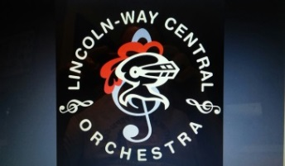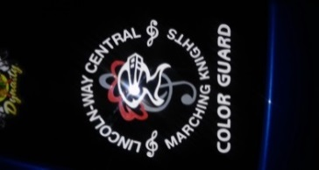 *Car Decals / Section Decals MK decal with Color Guard Section*

LWC Marching Knights $15.00 _____

LWC Orchestra $15.00_____

LWC Music $15.00 _____

Section Decals $5.00 each

**Alumni_____; Alto Saxophone_____; Baritone____; Bass Clarinet_____; Choir_____; Cello____; Color Guard____; Drum Line____; Drum Major____; Flute____; Madrigal Singer____; Mellophone_____; Piccolo____; Pep Band_____; Orchestra_____; Sousaphone_____; Tenor Sax____; Tenor Saxophone____; Trumpet_____; Violin____;**

**Name _____________________________________________ Phone_______________________**

**Address:___________________________________________ Payment from IBA ________**

**Order Total $_________ Check Number ________**

Make checks payable to: **LWCMB** Place order form in **Red Mail Box** in music room Or mail to LWCMB c/o Tim Cosgrove 1026 Stonegate Rd. New Lenox IL. 60451 Questions: Tim Cosgrove, 815-485-5599 or [sox1985@att.net](mailto:sox1985@att.net)

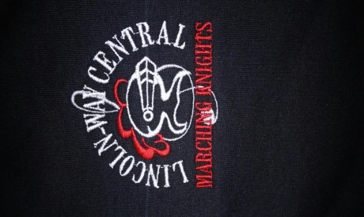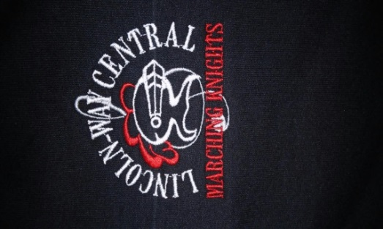 Option #1** Option#2**



LWC, Knight Head embroidery on garment shown with Embroidery on left leg of pants / shorts o MK section, Replace MK with another section Choose option 1 or 2 when ordering.

at no additional cost, see page 1 for information* Replace MK on option # 1 with another*** *Sections Available\*\*\**

….. Parent, Chamber Singers, Chorale, Color Guard,

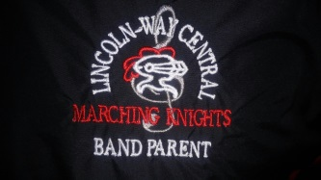 Guitar Studio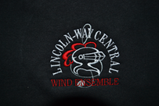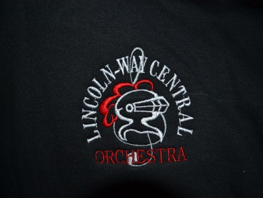, Jazz Ensemble, Madrigal Singers, Marching Knights

Orchestra, Pep Band, Percussion, Singing Knights, Treblemaker

Tri-M, Symphonic Band, Wind Ensemble, Winter Guard

Examples of embroidery

MK and Band Parent Wind Ensemble Orchestra

Many sections available see left side of page

[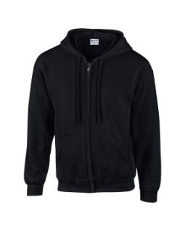](http://www.mygildan.com/p/12600/036?view=) 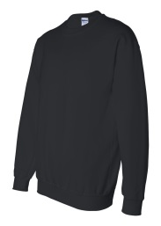

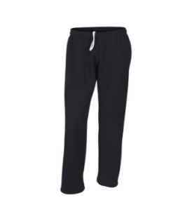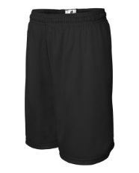

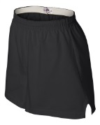

Zipper Hoodie Pull over Sweatshirt Sweat Pants Men’s Shorts Women’s Shorts

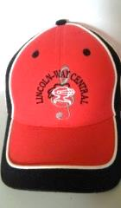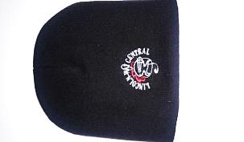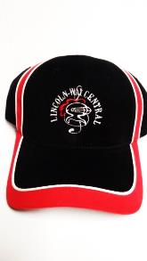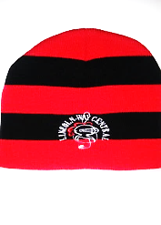

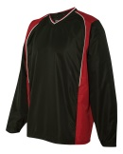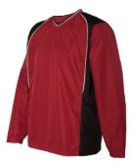

Red with Black Black with Red Black Knit Cap Red/Black Knit Cap Wind Shirt

Red/Black Black/Red

LWC, Knight Head, Treble Clef standard embroidery on all head gear

Add any section to back of caps for $8.00